

# 

COMPLAINT : 19090

DATE: 15/Mar/2022

The Manager,

BANK AL-HABIB

HJHJII,GUJ ZONE

Subject: Quotation of subject_line.

Number of AC: 1

|  |  |  |  |  |
| --- | --- | --- | --- | --- |
| Sr. | Job Description | Qty | Rate | Amount |
|  | Gas Charging ( upto to 2 Ton) Inverter AC Unit Unit | 3 | 4670.0 | 14010.0 |
|  | Gas Charging ( upto to 2 Ton) Inverter AC Unit Unit | 3 | 4670.0 | 14010.0 |
|  | Total |  |  | 0.00 |
|  | Tax 16% |  |  |  |
|  | Total |  |  | 0.0 |

**Yours truly,**

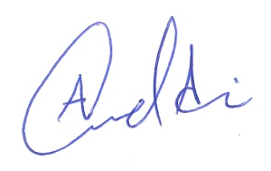 **ECO ENTERPRISES**